**The below steps will help eliminate the failure to launch various courseware issues encountered by (i.e., OPSEC, Records Management etc.) TECOM Civilian Marines and Uniformed Members.**

1. Launch Internet Explorer
2. Click "Tools"
3. Select Add-ons
4. Ensure that Java Plugin is enabled, close add-ons prompt
5. Select Compatibility View Settings
6. Ensure that both boxes are unchecked, and no .mil sites are found in the white box in this prompt
7. Restart IE

**IF CLASS STILL FAILS TO LOAD**

1. Open Control Panel
2. Select view small icons
3. Select Java
4. Select "Settings" under Temporary Internet Files
5. Clear Temporary Files, ensure all 3 boxes are checked
6. Select Security tab
7. Restore Security Prompts
8. Relaunch IE

**Additionally, the below steps will install Firefox as an alternate browser and enable .mil/.gov sites to function within that browser:**

1. Launch Software Center
2. Select and install Mozilla Firefox
3. Using bookmarks toolbar, import EU's favorites from IE
4. Enable EU's ActivClient in Firefox
5. Options **>** Privacy and Security **>** Security Devices > Load file listed below
6. "C:\Program Files\HID Global\ActivClient\acpkcs211.dll"
7. EU should be able to utilize **ALMOST** all .mil/.gov sites
8. If EU is unable to use a particular site, revert to IE for this function

**How do I fix Internet Explorer (IE) compatibility issues?**

1. In Internet Explorer, press the Alt key to display the Menu bar, or press and hold the address bar and select Menu bar.
2. Click Tools and select Compatibility View settings.
3. Add this website “Google.com”.
4. Remove all other additional website(s)
5. Click close.

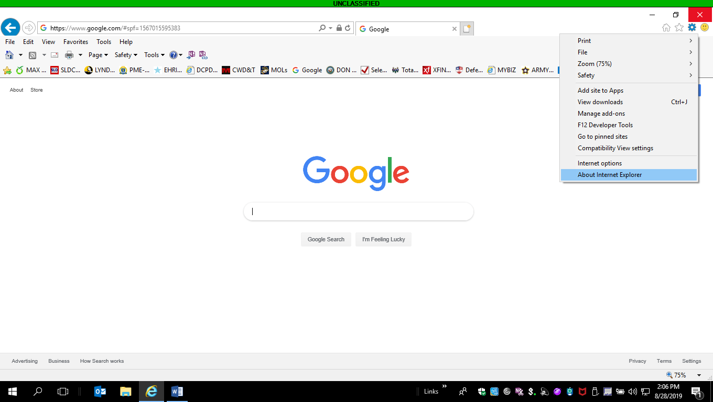 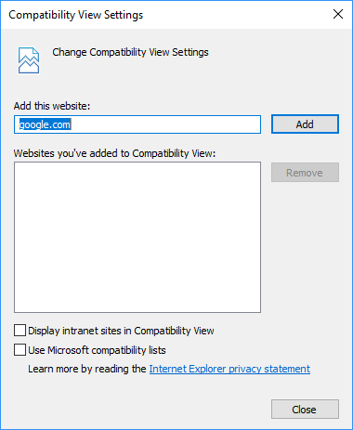

Or use the EDGE Browser:

